1. Difference between CP command and MV command

A. CP command is used to copy files from one directory to another directory.

MV command is used to move files from one directory to another directory. And we use this re name the flies, It will delete from while moving.

For example

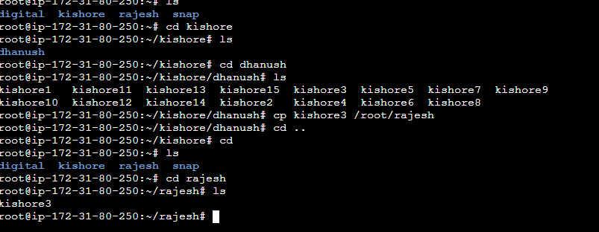



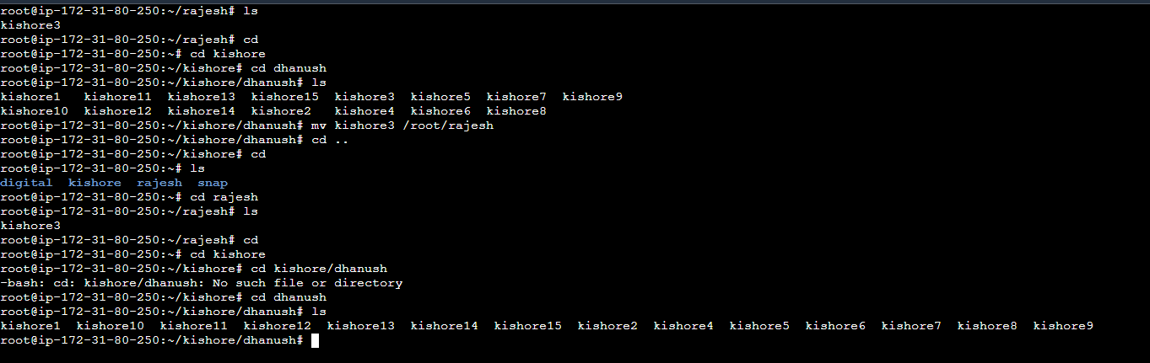

Remame the folder



